**Game Design Document (GDD)**

**Portfolio**

**“Echoes of the Unknown”**

Designed by: Andry Sukaputra

**Copyright © 2025 Andry Sukaputra. All rights reserved.**

**CHAPTER 1**

**CONCEPT SUMMARY**

**1.1 Introduction**

**“Echoes of The Unknown”** is a top-down shooter with elements of survival strategy, resource gathering, and base defense. Players must struggle on an alien planet after their ship crashes. They must fight dangerous creatures, uncover the mysteries of the planet, and repair their ship to escape by utilizing **“Echoes”** mysterious recordings from the future that can help or mislead the player.

**Audience Target:**

**Genre:** Shooter, Survival, Strategy

**Platform:** Mobile/Tablet (Android & iOS)

**Market Target:** Age 13+ years

**1.2 Story Background**

The year 2249 is a great era for humanity in space exploration. This is because the needs of humanity can no longer be accommodated by Earth. Earth's resources are estimated to be insufficient for all of humanity. An astronaut pilot who has passed rigorous space exploration training receives an exploration mission to review a planet that is possibly similar to Earth. Together with the crew, he begins a journey and adventure through the darkness of outer space. In the midst of the silence of outer space, he is suddenly confronted by an unexpected space anomaly. A cosmic storm hits their ship, he and the crew must defend their ship as best they can. In the midst of the fierce cosmic storm that destroys the ship, they must face another problem. The entire ship's system is currently not functioning, as if it has been sabotaged by something they do not know. He and the crew are forced to make an emergency landing and crash on a nearby planet. The entire crew is gone, now only he remains on a mysterious planet that is not even known to other humans. A planet with unique natural conditions, changing weather structures, ruins of ancient civilizations, and most terrifyingly, dangerous and manipulative aliens who call themselves “Echoes Hosts”. Together with an AI named “Kimi” that is still functioning, he wears an astronaut suit, takes equipment that can still be used, and a gun in hand. He decides to explore the mysterious planet, uncover the secrets behind it, survive, and try to find a way to return to Earth.

**CHAPTER 2**

**KEY FEATURES**

**2.1 Core Gameplay Mechanics**

In this section, we will explain the core mechanics of the game and how players can play **“Echoes of The Unknown”** such as character control, combat system, resource gathering, base defense, and the game’s final objective.

**2.1.1 Character Control & Perspectives**

Players can move freely in an open environment, avoid attacks, and build defenses. The game has a top-down shooter view with players being able to control the in-game character via a virtual joystick.

1. **Control Mechanics**

Players can control the character in the game with a virtual joystick to move and action buttons to shoot and interact. The User Interface (UI) of the virtual joystick is as follows.



**Figure 2.1 Joystick UI**

The joystick button is used as a character movement tool and player exploration through the character in the game. The button will always be there when the character is loaded in the game or the character is idle. The combat action button is used to carry out shooting attacks from the character. The button can be tapped to release one or more bullets and can be held to release bullets continuously. The combat action button is as follows.

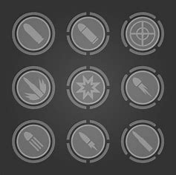

**Figure 2.2 Combat Action Button UI**

The combat action button will appear when the character is only in the combat zone or an enemy appears. Even though the character is in idle position and not in the combat zone, the combat action button will not appear. In addition to the combat action button as the main attack button, there are change weapon, quick heal, quick energy/stamina, and sub-weapon buttons near the combat action button as in the following example image.

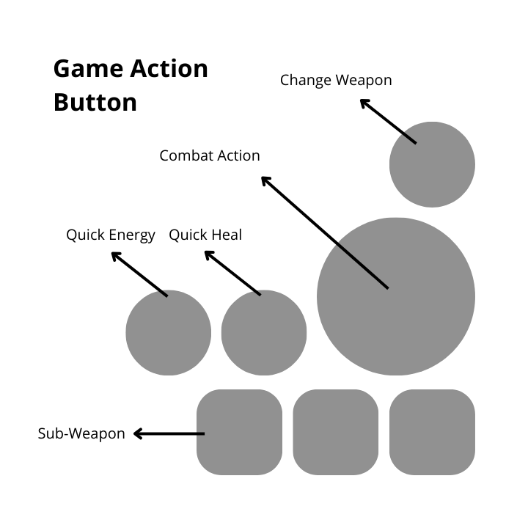

**Figure 2.3 Game Action Button**

The explanation of the action buttons is as follows.

1. **Combat Action:** The main button for attacks.
2. **Change Weapon:** The button to quickly change weapons in the item box. Players must first sort the weapons they want to use in battle.
3. **Quick Heal:** The button to quickly heal the character according to the type and number of heal items installed by the player.
4. **Quick Energy/Stamina:** The button to quickly energize the character according to the type and number of energy/stamina items installed by the player.
5. **Sub-Weapon:** The button to attack enemies with sub-weapons according to the type and number of sub-weapons installed by the player.

The Quick Energy/Stamina button is related to character movement and the joystick. If the player holds the direction of the joystick, in a few seconds, the character will automatically move quickly or run. The longer or more often the direction is maintained, the more the character's energy/stamina will decrease. The energy/stamina will be filled slowly if the character is in an idle position or walking. Therefore, the Quick Energy/Stamina button is used to speed up the filling of the character's energy/stamina based on the energy/stamina items installed.

The combat action buttons can change into interaction buttons as shown in the following image.



**Figure 2.4 Interact Button**

These interaction buttons will appear when the player interacts with an object in the game or is used to inspect something.

1. **Combination Mechanics**
2. **Shooting and Survival:** Players must use weapons against enemies while building structures to survive.
3. **Manipulate “Echoes”:** Players can find voice recordings and holograms from the future that provide clues, but some are traps.
4. **Enemy Adaptation:** Enemy AI learns player tactics and evolves, forcing players to constantly change their strategy.

**2.1.2 Combat System**

In the combat system in the game using an exponential wave system along with the development and level of the character. The type of wave and the type of top-down shooter can refer to the classic game references Alien Shooter (2003) or Hotline Miami (2012) as follows.

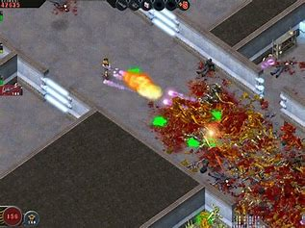

**Figure 2.5 Alien Shooter (2003)**

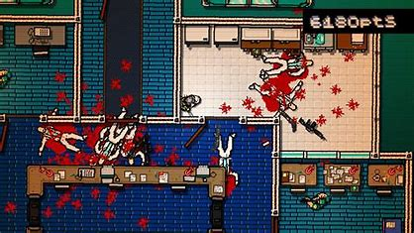

**Figure 2.6 Hotline Miami (2012)**

Or newer ones like the games Ruiner (2017) and The Hong Kong Massacre (2019) as follows.

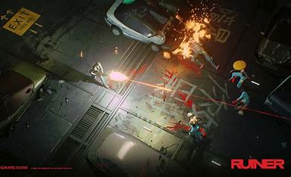

**Figure 2.7 Ruiner (2017)**

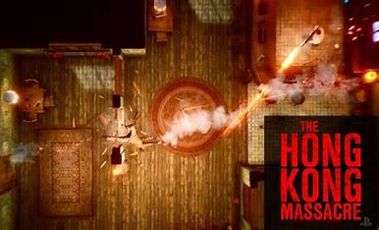

**Figure 2.8 The Hong Kong Massacre (2019)**

The battle action occurs when the player is exploring, entering new areas and places, or a dungeon for game missions, resource gathering, or just free exploration. The purpose of the battle that the player must face is made waves that come to make the game atmosphere more immersive and full of action.

In battle, players can use weapons such as pistols, rifles, grenades, and others that have been installed on the character or in the item box to fight waves of enemies. The weapons used by players in battle also have different levels that can be obtained by upgrading existing weapons with several items or combining resources found on the planet. Weapon categories can be divided as follows.Weapons, merupakan senjata utama yang dipasangkan pemain untuk karakter.

1. **Weapons consist of:**
2. **Pistol:** The smallest weapon and also has the smallest shooting damage in the game, but has a shooting range that is quite far beyond the Shotgun, but not as far as the Rifle.
3. **Shotgun:** A shooting weapon that has high damage with bullets that spread. This weapon has a close shooting range, not effective for long-range shots.
4. **Rifle:** A shooting weapon that has medium damage and shooting range. The ability of this weapon is the most flexible for attacking, so it can be used in various battles.
5. **Flame Gun:** A shooting weapon that emits fire. Suitable for fighting crowds of enemies by continuously dealing damage when the enemy is on fire.
6. **Machine Gun:** A machine gun with large caliber bullets. Suitable for fighting crowds of enemies by dealing large damage repeatedly. However, the use of this weapon burdens the character's movement.
7. **Plasma Gun:** A weapon that can shoot plasma lasers that can destroy crowds of enemies in one or just a few shots. This weapon has the greatest damage. However, the use of this weapon burdens the character's movement and can only be used a few times.
8. **Sub-Weapons,** are support weapons that players equip to their characters. **Sub-Weapons consist of:**
9. **Explosive Grenade:** A grenade that has a bomb explosion with a certain radius that has high damage.
10. **Fire Grenade:** A grenade that has a fire explosion with a certain radius that has continuous damage and the fire effect can spread to several enemies around in a few seconds.
11. **Stun Grenade:** A grenade that has an electric shock with a certain radius that has a stun effect on several enemies around it. This grenade has no damage, but can stop enemy movement for a few seconds.
12. **Glue Grenade:** A grenade that has a glue-like liquid with a certain radius that has the effect of slowing down enemy movement.
13. **Plasma Grenade:** A grenade that has a plasma explosion with the widest radius and the highest damage in the game.

In addition to weapons, enemies in the game also have certain variations. These variations make enemies have unique attack patterns that require different strategies. Starting from ordinary aliens that can be killed with one or two attacks to aliens that require more effort to be killed. Enemies or aliens in this game are called **“Echoes Hosts”** which are shaped like primates such as chimpanzees, baboons, or monkeys with a mixture of machines or androids due to the **“Echoes”** effect. Some types of aliens in the game are as follows.

1. **Normal:** The normal type of alien on the planet. Easy to defeat but their numbers are the most and usually in groups.
2. **Runner:** Aliens who have the fastest movement or running ability in the game.
3. **Acid:** Aliens who can shoot liquids like acid. If hit, the character will receive continuous damage for several seconds.
4. **Tank:** Large and stocky aliens with one of their hands larger that almost covers most of their body. The attack damage they have is high, but the combination of attacks is simple.
5. **Bomb:** Large, fat aliens who can explode themselves if attacked continuously which can also provide area damage to anything around them. The alien will explode if it is close to the character within a certain distance without having to be shot. The closer to the explosion, the greater the damage received.
6. **Mage:** Aliens who can float and have robes like wizards. These aliens can issue attacks in the form of certain elements and effects. This alien is the most intelligent type. Can use **“Echoes”** as a weapon to manipulate.

**2.1.3 Resource Gathering and Management**

In general, players must find resources for game needs that are scattered on the map. These resources are used to upgrade weapons, bases, and repair previously damaged ships. In-game resources are crucial items for character progress and survival in the game. Some types of in-game resources are as follows.

1. **Rock Minerals:** Used to build, upgrade, create defensive structures, and character life necessities.
2. **Crystal Minerals:** Used to build, create, and upgrade defensive structures, weapons, and energy. Also needed to repair aircraft parts.
3. **Metals:** Used to build, create, and upgrade defensive structures, weapons, and character life necessities. Also needed to repair aircraft parts.
4. **Electronic Components:** Used to build, create, and upgrade defensive structures, weapons, and character life necessities. Also needed to repair aircraft parts.
5. **Echoes:** Used to upgrade energy, automatic weapons, repair aircraft parts, upgrade the AI ​​“Kimi”, and unlock the mysteries of the planet for game progress.
6. **Energy:** Needed to activate automatic weapons, shields, and generators.
7. **Fabric:** Needed to upgrade character life necessities and repair aircraft parts.
8. **Food and Water:** Needed to keep the character's health and stamina high.

**The method for collecting resources is as follows:**

1. Destroying unused aircraft debris.
2. Destroying unused equipment.
3. Exploring places around the map.
4. Looting from defeated enemies.
5. Mining in locations scattered around the map.
6. Collecting plants.
7. Farming or collecting rainwater.
8. Buying from Special Merchants (in-game purchases).

**The Resource Management Strategy in the game is as follows:**

1. All items obtained by the player will be in the backpack item box.
2. Players can store all items into the cabinet item box.
3. Players must balance between using resources to survive and repair the plane.
4. Bad decisions can lead to resource shortages, slow player progress, or defeat in the game.

This concept of exploration and resource management is similar to the games Astrometica (2024) and Durango: Wild Lands (2018) as follows.

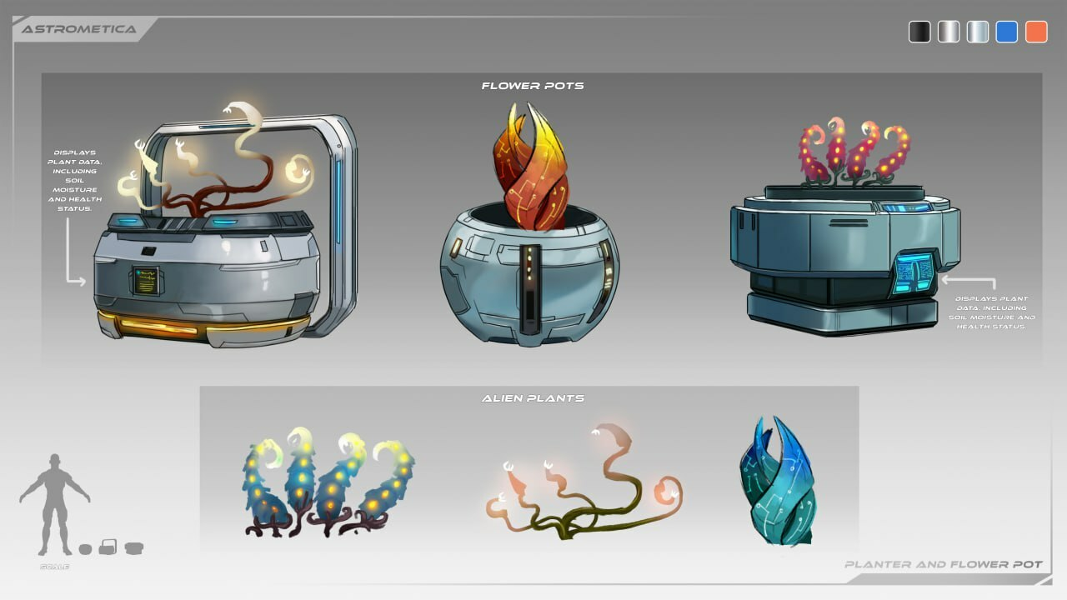

**Figure 2.9 Astormetica (2024)**

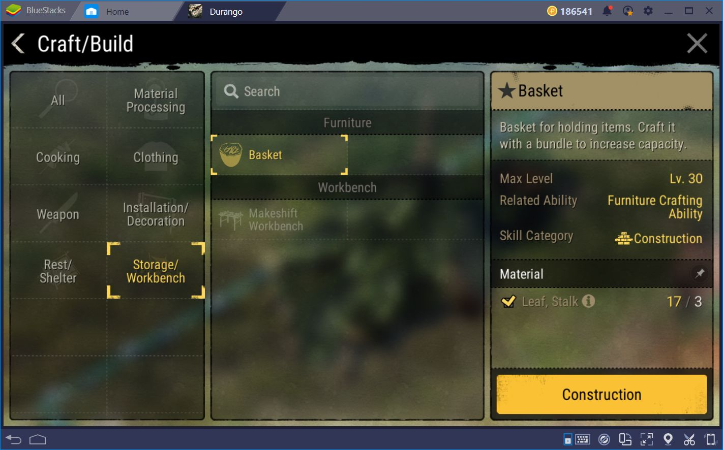

**Figure 2.10 Durango: Wild Lands (2018)**

This means that players must prioritize their strategy based on their playing style. All stages of resource management will follow the progress of the game. The higher the character level, the more complex the resource management strategy will be, because the need for in-game items will also increase.

**2.1.4 Base Defense and Upgrades**

The enemy attack wave on the base has a certain time. Players can build various defensive structures such as walls, automatic shooting towers, signal towers, and traps that can be developed as the game progresses. The enemy attack wave that attacks the base will occur in a certain period of time, so players can prepare for it. During the enemy attack wave, players can be in the base or not in the base. If the player chooses not to be in the base, then the player must ensure that the defense weapons they have can attack automatically.

Defense and base upgrades are intended to protect the player's resources from waves of enemy attacks. If the player's base is destroyed, the player does not immediately lose the game. However, all resources stored in the base will be destroyed and lost, so the player must do it again from the beginning. The higher the level of the player and base, the higher, stronger, and more intense and varied the enemies that attack.

The defense structure in the game has various forms according to the resources used by the player. For example:

1. **Mineral Stone Wall:** Withstands enemy attacks at low levels.
2. **Metal Wall:** Withstands enemy attacks longer.
3. **Auto Turret:** Can be customized with various types of weapons.
4. **Signal Tower:** Can be used to open map areas and early warning of enemy attacks.
5. **Traps:** For example, electric traps are used to paralyze enemies for a few seconds.
6. **Shield:** Serves as a layer of defense against enemy attacks.

**The headquarters upgrades and customizations are as follows:**

1. Players can upgrade the wall's durability, tower firing speed, range, shield thickness, and trap effectiveness.
2. Players can choose various defense designs according to their playing style and strategy.
3. There is a progression system that allows players to unlock new blueprints for more advanced defenses.
4. Players can also upgrade life necessities such as food and water.

For the character's life necessities, an example can be found in the film The Martian (2015) as follows.

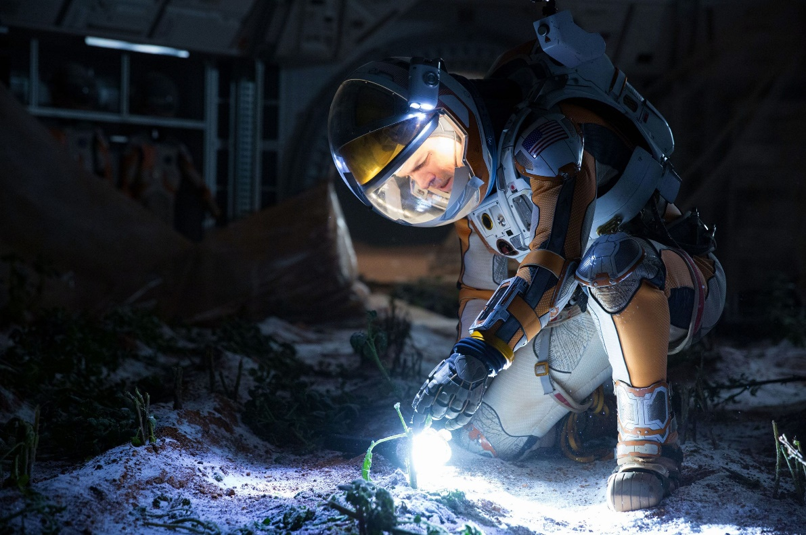

**Figure 2.11 The Martian (2015)**

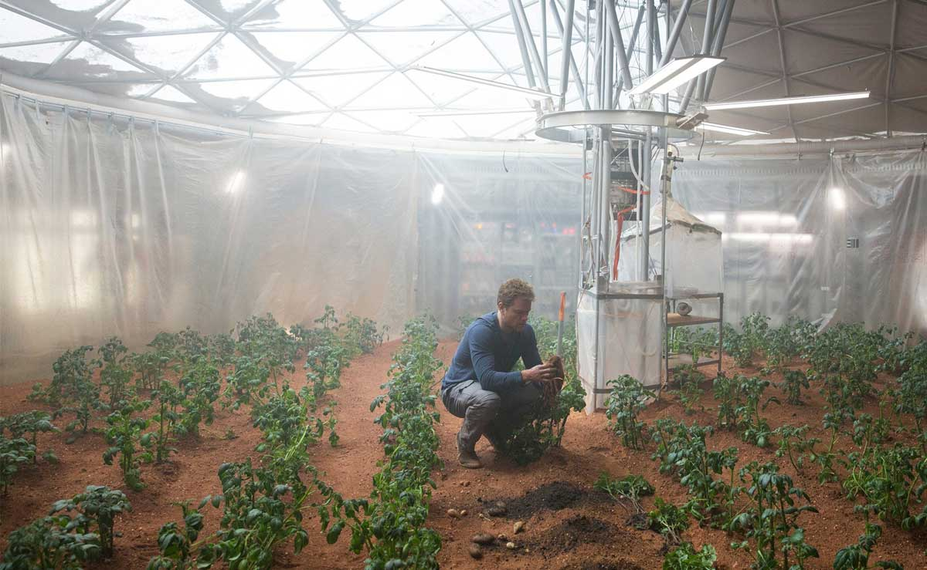

**Figure 2.12 The Martian (2015)**

In essence, combat weapons and base defense will always be related to in-game resources. Good optimization and management will depend on each player.

**2.1.5 Final Goal**

The player's ultimate goal is to survive, build the best base possible, uncover the mysteries of the planet, and repair his ship to return to Earth.

* 1. **Progression and Customization**

Further development and customization in the game can be done by:

1. **Leveling System:** Players gain XP from killing enemies, completing missions, collecting resources, and building defenses.
2. **Unlockable Skills and Weapons:**

* **New Weapons:** Advanced weapons or sub-weapons can be obtained through blueprints and crafted with specific resources. In-game blueprints can be obtained through document fragments following character progress and level.
* **Special Abilities:** Such as sprinting, energy shields on characters, or defense drones can be obtained as character levels increase. Players are free to choose special abilities depending on their playing style. These special abilities do not reduce character energy/stamina points, but have a certain time limit when used. Players can also increase their special abilities with certain items.

1. **Character and Base Customization:**

* Players can choose a character gender in this game at the start of the game, but no more (Gender Lock).
* Players can change the appearance of the character with various skins obtained through achievements or buying them at Special Merchants.
* The layout and management of the base can be customized based on the player's defense strategy.

**2.3 Atmosphere**

**2.3.1 Visual**

The game can use visual styles such as pixel-art or a modern visual style with a futuristic color palette combined with neon effects that reflect outer space technology and atmosphere.

* + 1. **Music and Audio**

The game can use a thrilling electronic soundtrack or other instrumental compositions that depict a mysterious and dangerous space. Realistic sound effects can be used for combat to create an immersive atmosphere. Some audio style references that can be reviewed are as follows:

1. Hans Zimmer: Interstellar (2014), Dune (2021 & 2024).
2. Steven Price: Gravity (2013).
3. John Williams: Jaws (1975).
4. Erik Aadahl & Ethan Van der Ryn: Quite Place (2018).

**2.3.3 Environment**

The ever-changing landscape of an alien planet with dynamic weather effects. Some references that can be used for the landscape or illustration of the planet are as follows.



**Figure 2.13 Starfield (2023)**

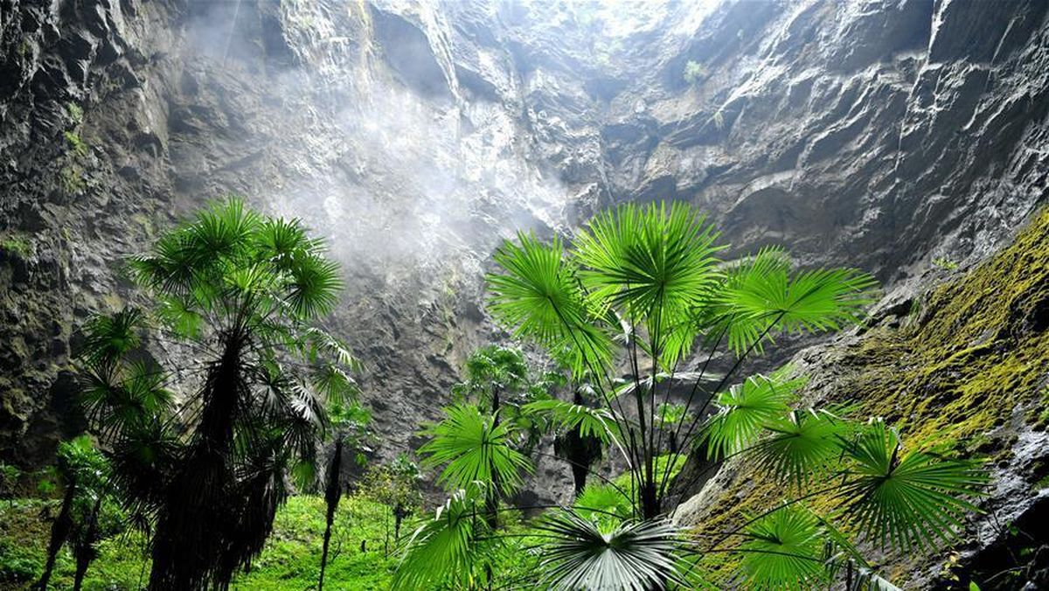

**Figure 2.14 Ancient Forest of Guangxi Zhuang Autonomous Region, China**

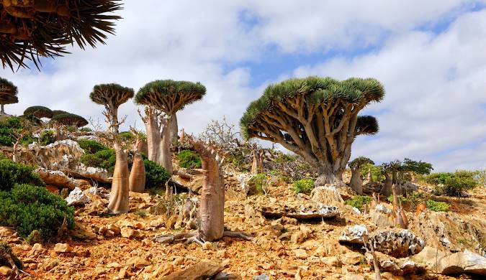

**Figure 2.15 Socrota Island, Yaman**

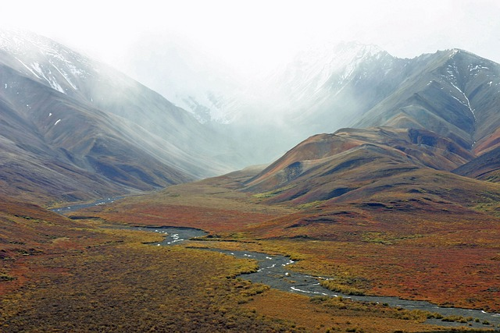

**Figure 2.16 Alaska Tundra Mountains**



**Figure 2.17 Atacama Desert, Chile**

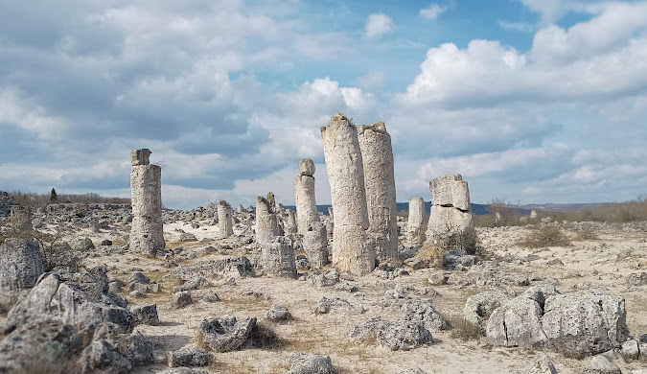

**Figure 2.18 Stone Forest, Bulgaria**

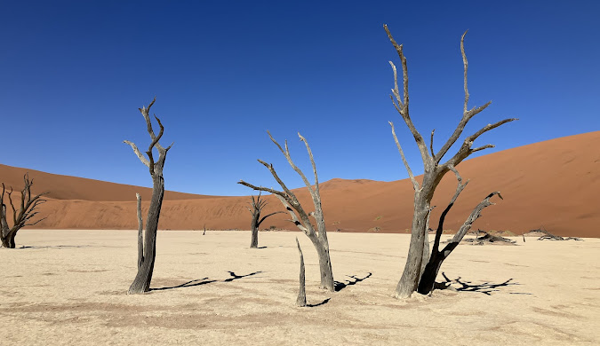

**Figure 2.19 Namib Desert, South Africa**



**Figure 2.20 The White Desert, Egypt**

* 1. **Additional Features**

1. **Multiplayer Co-op Mode:** Players can team up with friends to survive longer and split the task between attacking and defending bases.
2. **Daily Challenges and Events:**

* Special missions that provide exclusive rewards such as weapon and character skins.
* Seasonal events with special enemies and unique challenges.

1. **Leaderboards and Achievements:**

* Global and regional leaderboards for high scores and special achievements.
* Achievement system that rewards players who successfully reach certain targets.

1. **Monetization:**

* Advertisements with skip after a few seconds for free players.
* In-app purchases (Special Merchants) for character skins, premium weapons, and resource boosters.
* Battle pass system with exclusive rewards.
  1. **Technology and Development Team**

1. **Engine:** Unity 2D
2. **Team:** Approximately 10 people, with the following distribution:

* 2 Programmers
* 2 Artists
* 2 Designers
* 2 Sound Engineers
* 2 QAs

1. **Estimated Development Time:** around 8-12 months
   1. **Game Uniqueness**
2. **“Echoes Manipulation” Mechanic:**

* Players can find voice recordings and holograms from the future that give clues about enemy attacks.
* Some Echoes help players with real information, but others are alien engineering that misleads.

1. **Enemy AI That Learns from Players:**

* Each time players defend against an attack, enemies will learn their defensive patterns and adjust their strategies.
* This forces players to constantly change tactics and adapt.

1. **Ships as “Sentient Bases”:**

* The previously crashed ship has an AI named “Kimi” that continues to evolve over time.
* This AI can provide strategic advice, but also has a unique “personality” and can challenge the player’s decisions if they make a fatal mistake.
* As the game progresses, players can choose whether to upgrade this AI into a true ally or limit its awareness for safety.

1. **Changing Seasons and Planet Dynamics:**

* Planets are not static with changing seasons that affect terrain and survival strategies.
  1. **Conclusion**

**“Echoes of the Unknown”** game brings an innovative survival shooter experience with strategy elements and evolved AI. With an immersive atmosphere and unique features, this game is ready to offer an unprecedented challenge.